SIMATS ENGINEERING
ASSESSMENT TOOL 2

Annexure A
CONCEPT MAPPING

- A partially completed concept map is given below:
Application → Presentation → ______ → Transport → Network → ______ → Physical.
Analyze the missing layers and explain how their functions are essential for reliable communication.

ANSWER:

Completed Concept Map:
Application → Presentation → Session → Transport → Network → Data Link → Physical
Missing Layers:
Session Layer
Data Link Layer
Functions:
Session Layer: Establishes, manages, and terminates communication sessions between devices.
Data Link Layer: Provides error detection, framing, and reliable node-to-node data transfer using MAC addresses.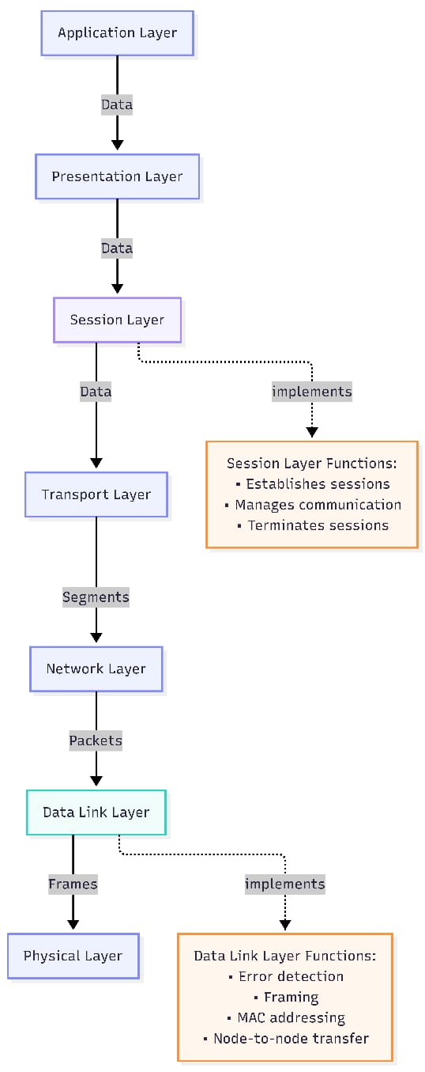

- Construct a concept map linking data units (Segment, Packet, Frame, Bits) with their respective OSI layers and analyze how transformation of data units supports transmission.

ANSWER:
Concept Map:
Transport Layer → Segment
Network Layer → Packet
Data Link Layer → Frame
Physical Layer → Bits
Analysis: As data moves down the OSI model, it changes from Segment → Packet → Frame → Bits for transmission. At the receiver, the process is reversed, ensuring accurate communication.

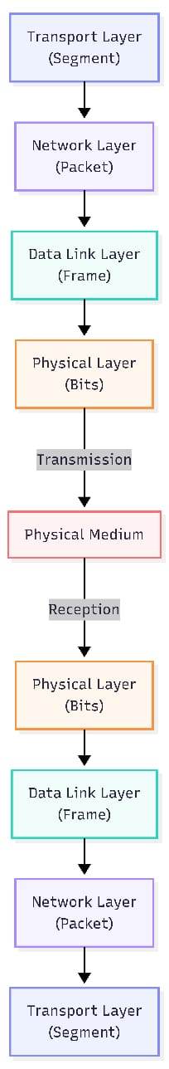

3.Given the concept map:
DataLink→MACAddress→LocalDelivery
Network → IP Address → Global Delivery
Explain how these relationships ensure complete data delivery across networks.

ANSWER:

Concept Map:
Data Link → MAC Address → Local Delivery
Network → IP Address → Global Delivery
Explanation:
MAC Address identifies devices within the same local network.
IP Address identifies devices across different networks.
Together, MAC and IP addresses ensure complete data delivery from source to destination.
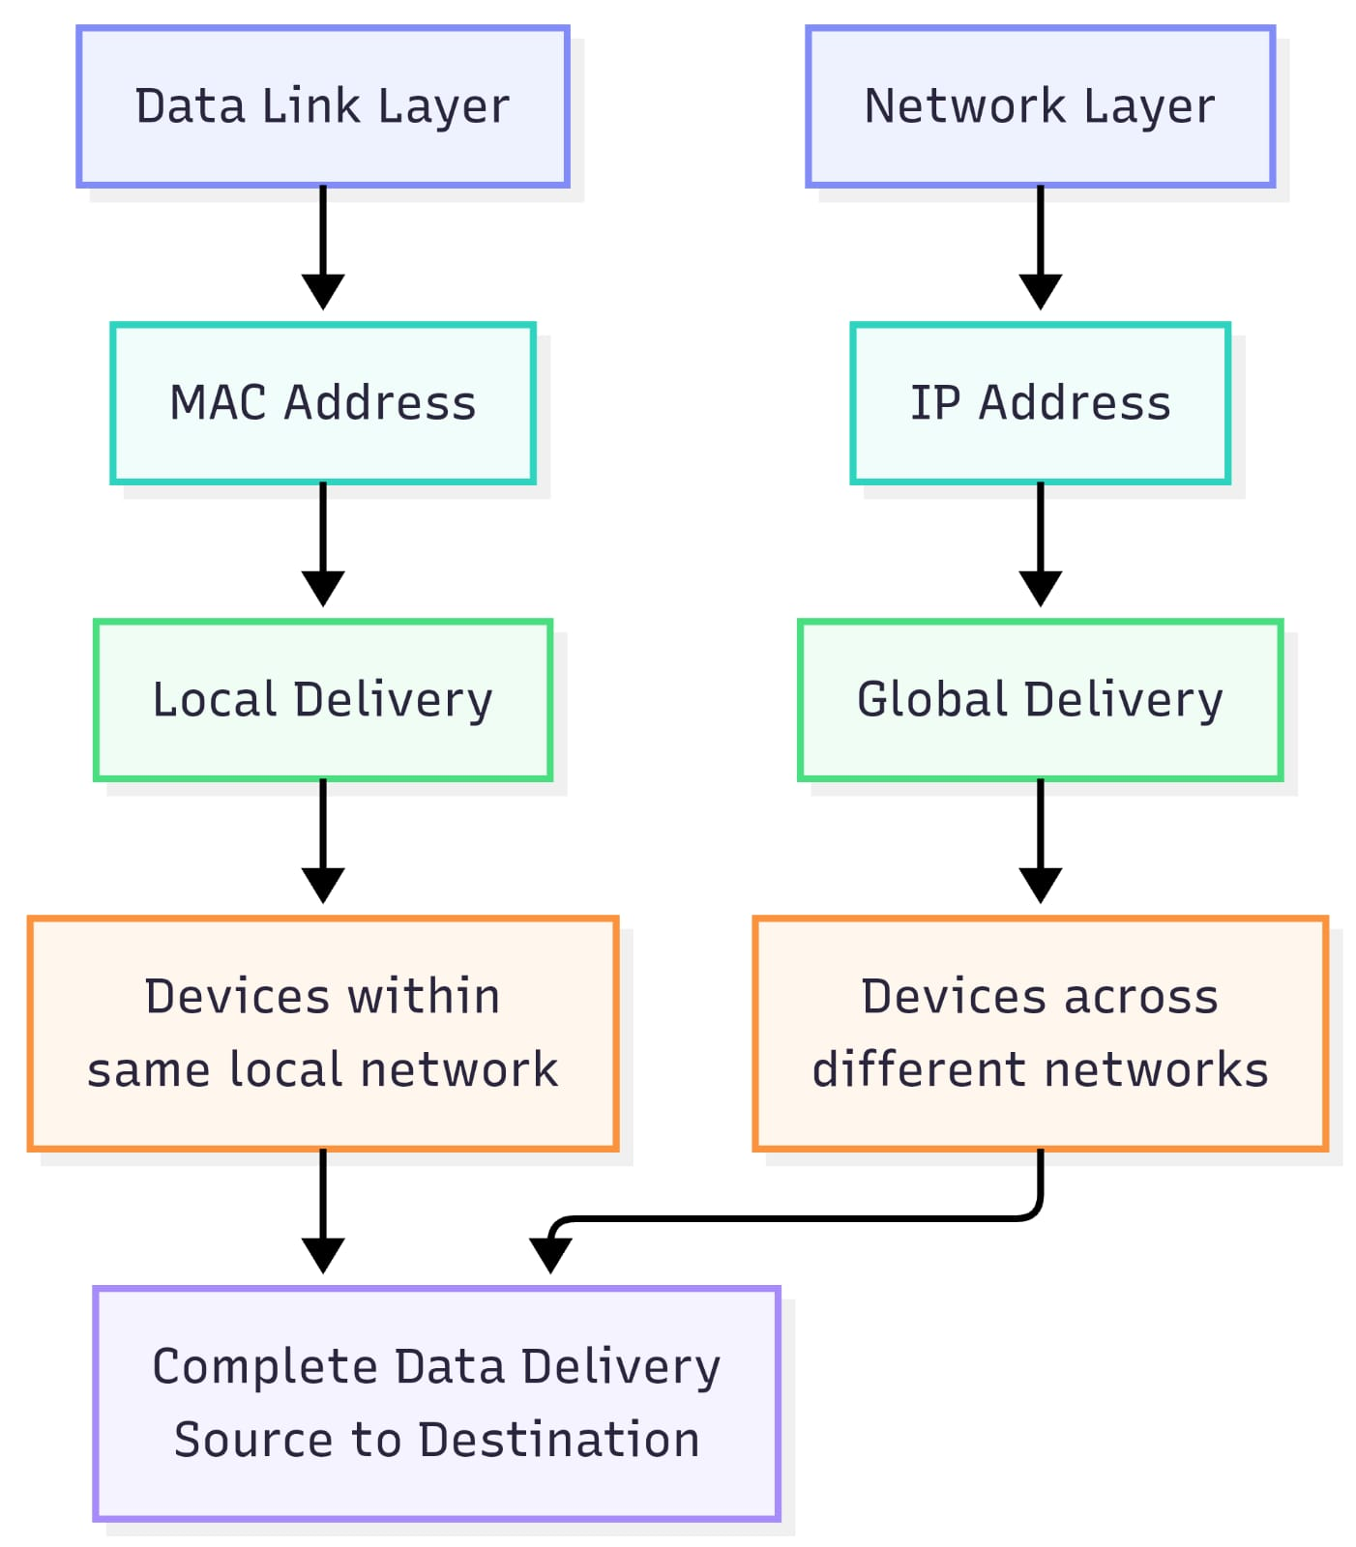

4. A concept map shows:
ErrorControl →DataLinkLayer→ErrorDetection
→ Transport Layer → Error Correction
Analyze how the interaction between these layers improves reliability in data transmission.
ANSWER:

Concept Map:
Error Control
→ Data Link Layer → Error Detection
→ Transport Layer → Error Correction
Analysis: The Data Link layer detects transmission errors using techniques like CRC, while the Transport layer ensures reliable delivery through acknowledgments and retransmission. Together, they improve communication reliability.

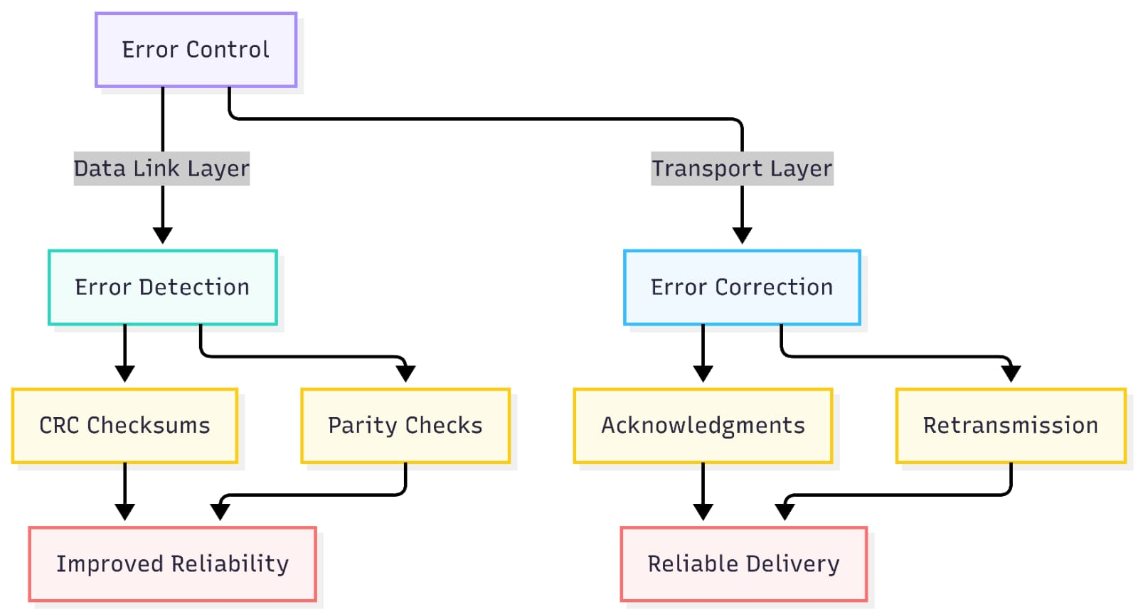

5. Develop a concept map for web browsing using OSI layers and analyze how failure in one layer affects the entire communication process.

Concept Map:
Application (HTTP/HTTPS)
↓
Presentation (Encryption/SSL)
↓
Session (Session Management)
↓
Transport (TCP)
↓
Network (IP Routing)
↓
Data Link (MAC Address)
↓
Physical (Cables/Wi-Fi)
Analysis: If any layer fails, web browsing is interrupted. For example:
Physical failure → No connection.
Network failure → Website unreachable.
Transport failure → Data loss.
Application failure → Browser cannot load the webpage.
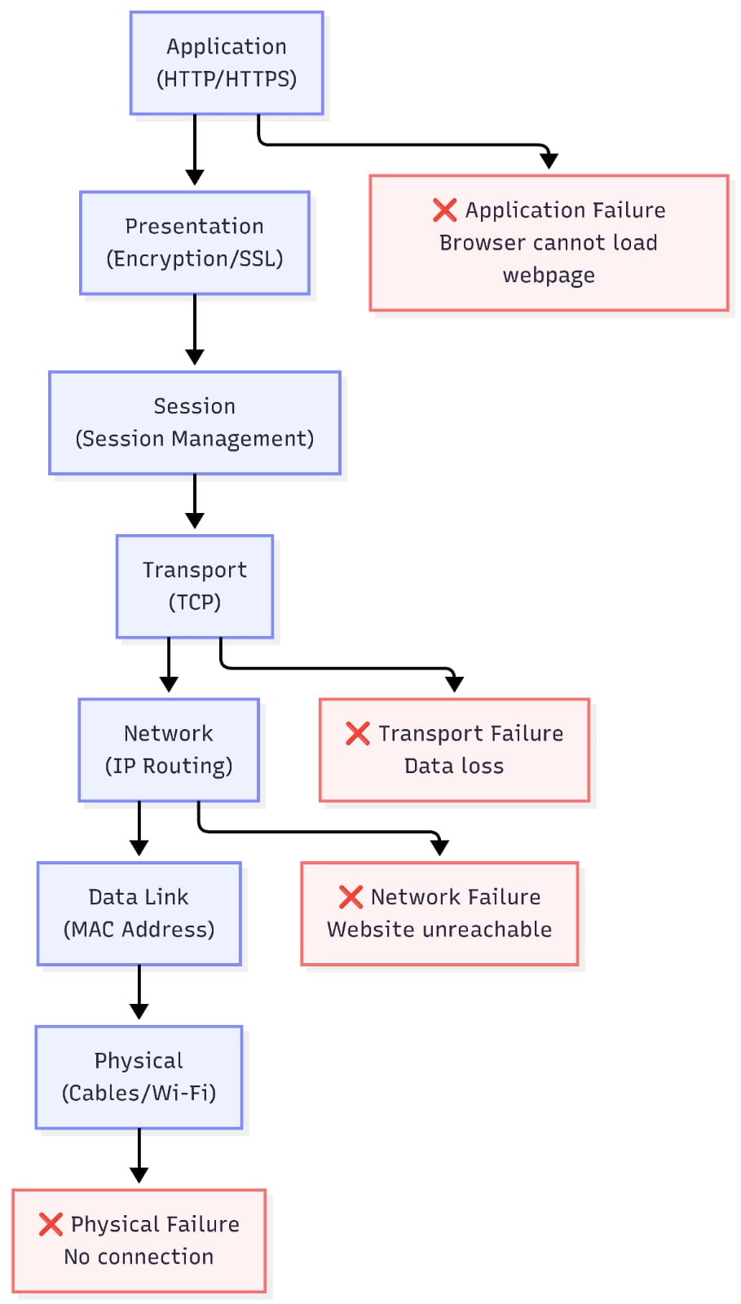

6. A network issue is represented in the concept map:
Physical ✔ → Data Link ✔ → Network ✖ → Transport ✖ → Application ✖
Analyze the problem and explain how the concept map helps in troubleshooting.

ANSWER:

Concept Map:
Physical ✔ → Data Link ✔ → Network ✖ → Transport ✖ → Application ✖
Analysis: The Physical and Data Link layers are working correctly. The problem starts at the Network layer, likely due to an incorrect IP address or routing issue. Since higher layers depend on the Network layer, the Transport and Application layers also fail.
Troubleshooting Steps:
Check IP address configuration.
Verify router and routing table.
Test connectivity using ping.
Check gateway and DNS settings.

